Date: March 27, 2026
Lesson plan Screen
This purpose of the screen is to allow user to create lesson plan using custom fields, external source or AI. We should allow the user to upload assets and share them with other users. When they upload the assets or save the lesson plan, the UI should prompt them to allow share option. The allow share option will allow the share globally, particular user(s)

Lesson Plan Builder with custom option
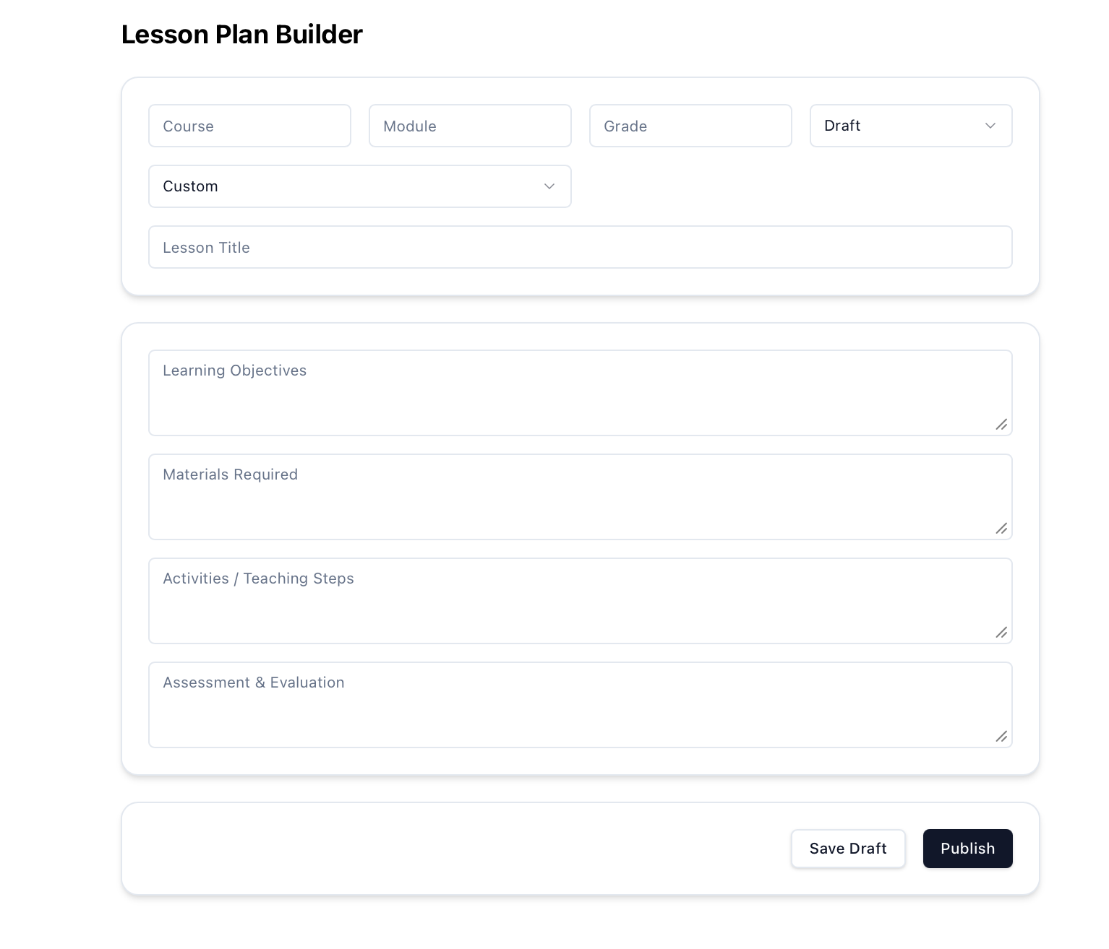

Lesson Plan builder with external source option
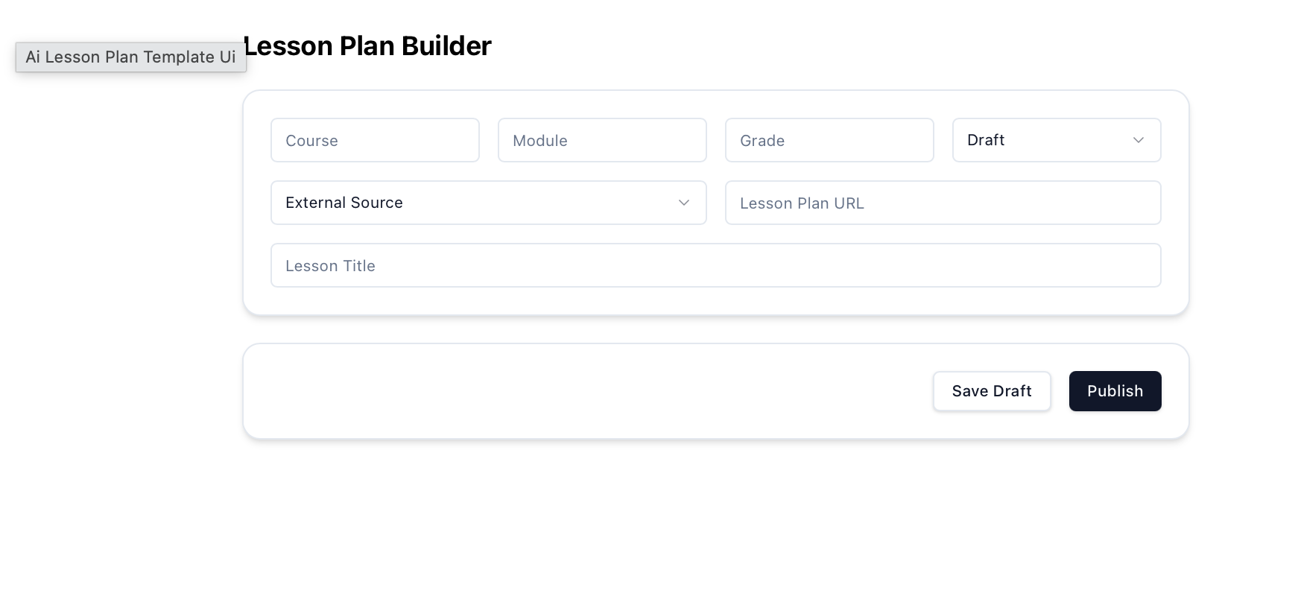
Lesson Plan builder with AI option

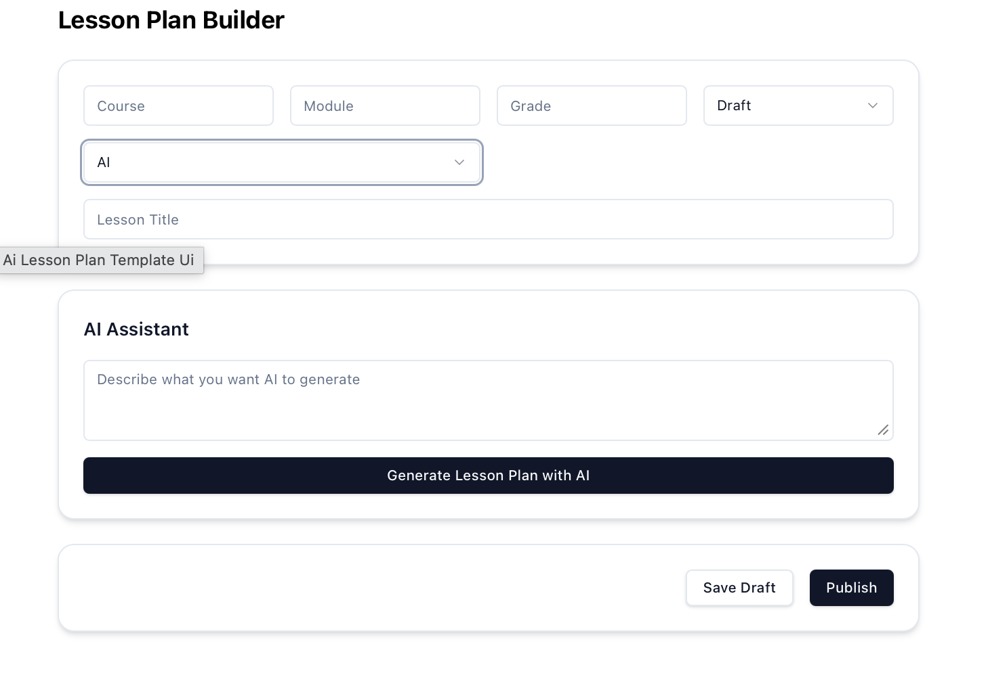
Note:
- Add ‘Type’, and ‘Compliance Code’ fields below the course, module row. The type will indicate the activity type – lesson, project, discussion etc.. and compliance code will be entered by the user (CBSE901A, 417 etc..)
- The status field will have options ‘Draft’, ‘Active’, ‘Inactive’ or ‘Deleted’.
- When the lesson plan is saved or published, the author, last saved or published date should be displayed in the view page.
- In lesson plan summary page as a list or card view, the user should be able copy(Duplicate) an existing lesson plan. They can make changes and use it for other lesson plan.
- In the summary page or in lesson plan detail page, we should add ‘Print’, ‘Approve’ and ‘Download’ options.
  - If the lesson plan is created by external user and submit for approval by them, then the ‘Approve’ button should be display for the teacher who is assigned with the approval of the lesson plan
  - The ‘Download’ option should allow the user to download the lesson plan in PDF version.
  - The ‘Print’ option should allow the user to print the lesson plan to their local printer.

